Insights
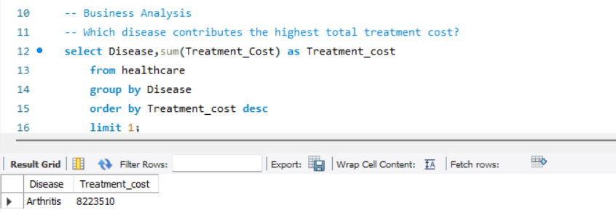
In Arthritis Diseases total treatment cost is 8223510

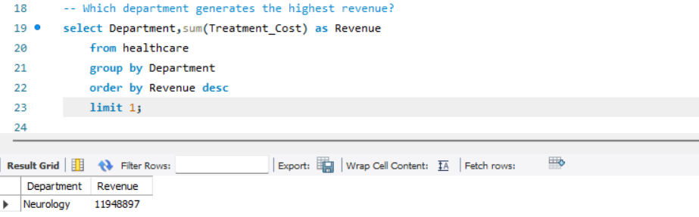
Neurology Department has Highest Revenue it is 11948897
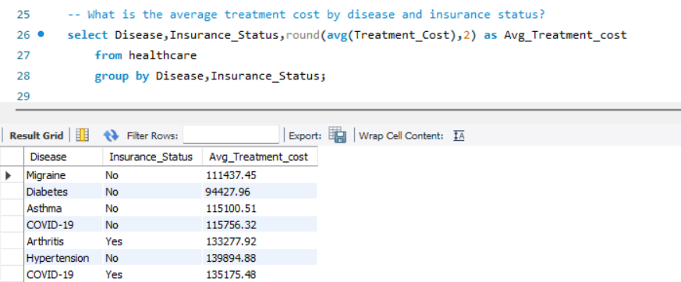
This show avg diseases cost by insurance status it approx 48-49% amount depend on patient paying and 51-52 % on Insurance
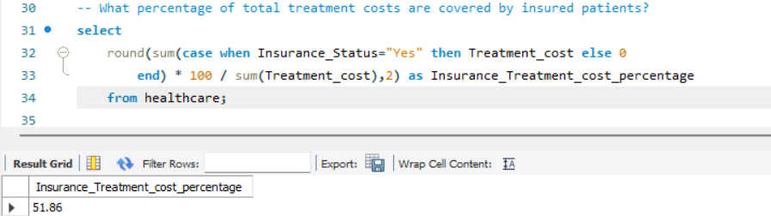
Here we can see that the 51.86 % amount paid by Insurance , insured patient treatment cost is more than non- insurance people , because people spend freely because insured is paying .

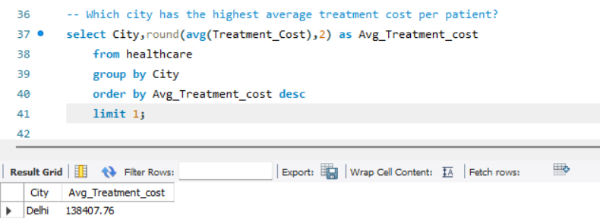
Delhi City has the highest average treatment cost it is 138407

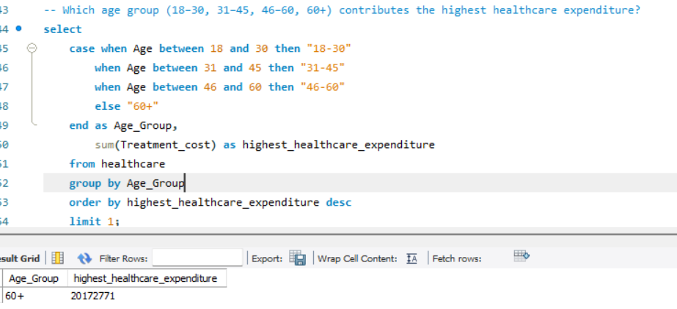
60+ age group peoples constributes highest expenditure
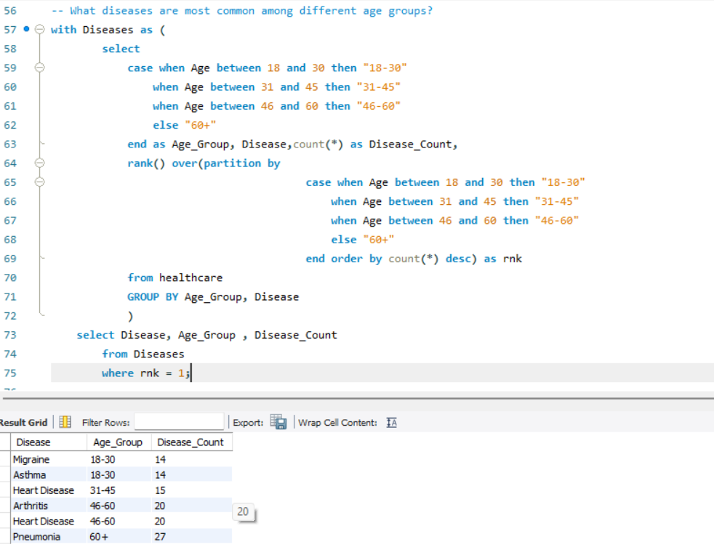
Most common diseases to different age groups has migraine and Asthma has 18-30 Age Group peoples

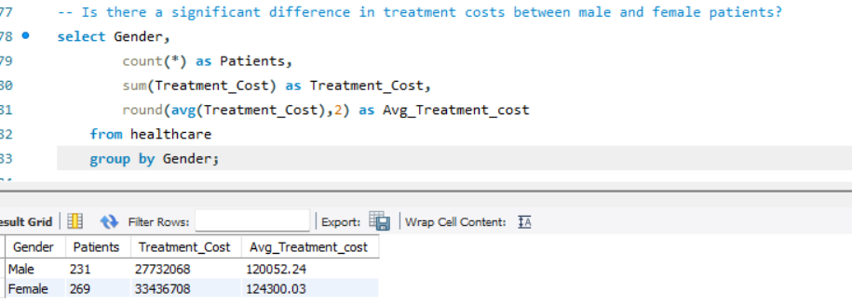
There Female patient and Revenue is more than Male
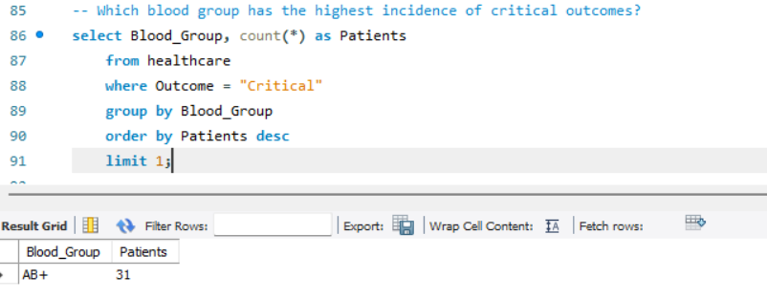

AB+ Blood Group has the most critical cases, 31 patients

